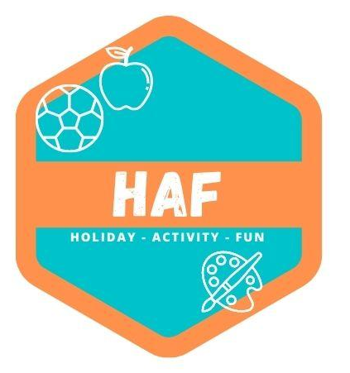

Administering Medication Policy
If a child attending West Lancs HAF requires prescription medication of any kind, their parent or carer must complete a Permission to administer medicine form in advance or when dropping off. Staff at the Camp will not administer any medication without such prior written consent.
Ideally children should take their medication before arriving at the camp. Camp staff will keep the medication safe until it is required. All medication must be labelled with the child’s name including inhalers.
West Lancs HAF can only administer prescribed medication that has been prescribed by a doctor, dentist, nurse or pharmacist. However, if a medicine contains aspirin we can only administer it if it has been prescribed by a doctor. All prescribed medication provided must have the prescription sticker attached which includes the child’s name, the date, the type of medicine and the dosage.
A designated staff member will be responsible for administering medication or for witnessing self-administration by the child. The designated person will record receipt of the medication on a Medication Log, will check that the medication is properly labelled and will ensure that it is stored securely during the session.
Before any medication is given, the designated person will:
• Check that the camp has received written consent
• Ask another member of staff to witness that the correct dosage is given.
When the medication has been administered, the designated person must:
• Record all relevant details on the Record of Medication Given form
• Ask the child’s parent or carer to sign the form to acknowledge that the medication has been
given upon collection at the end of the day.
When the medication is returned to the child’s parent or carer, the designated person will record this on the Medication Log. If a child refuses to take their medication, staff will not force them to do so. The camp manager and the child’s parent or carer will be notified, and the incident recorded on the Record of Medication Given.
Certain medications require specialist training before use, e.g. Epi Pens. If a child requires such medication the camp manager will arrange appropriate training prior to that child’s attendance to camp. It may be necessary to absent the child until such training has been undertaken. Where specialist training is required, only appropriately trained staff may administer the medication.
A child’s parent or carer must complete a new Permission to Administer Medication form if there are any changes to a child’s medication (including change of dosage or frequency).
If a child suffers from a long-term medical condition the camp will ask the child's parents to provide a medical care plan from a medical professional, to clarify exactly what the symptoms and treatments are so that the camp has a clear understanding of the child's medical requirements.

This policy was adopted by: West Lancs HAF | Date: 20/03/2023
Reviewed on: 21/06/25  To be reviewed: 21/06/26 |   Signed: M.Forster

